**IOT BASED SMART PARKING SYSTEM**

A project report submitted in partial fulfilment

Of the requirements for the degree of B.Tech in

###### Information technology

##### By

A. NAGADEEPA (513221205009)

**Under the supervision of**

**Professor & HOD Department of Information Technology.**

**SMART PARKING SYSTEM**

# *Phase 3: Development part 1*

## Smart Parking System. The Modern Trend or a Growing Need?

Parking problems are not uncommon, especially for big cities. By 2023, market spending for smart parking products and services is expected to grow at a CAGR of 14% and surpass $3.8B according to an [IoT Analytics report](https://iot-analytics.com/smart-parking-market-report-2019-2023/). The growth of market spending is good news because it will force people to try to find a solution to these traffic problems instead of taking no action.

The problem is quite obvious. But a bigger question is what can technology do to solve it? Is there any way to solve the problem?

### **Why Are Entrepreneurs Investing in IoT Based Smart Parking System Development?**

Finding parking has become arduous whether you live in the USA, Europe, Australia, or India. When visiting a shopping mall, grocery store, or other popular places, you must have found it hard to find a parking spot for your vehicle. For this very reason, the investors are partnering with IoT-based smart parking system development companies to avoid further parking. 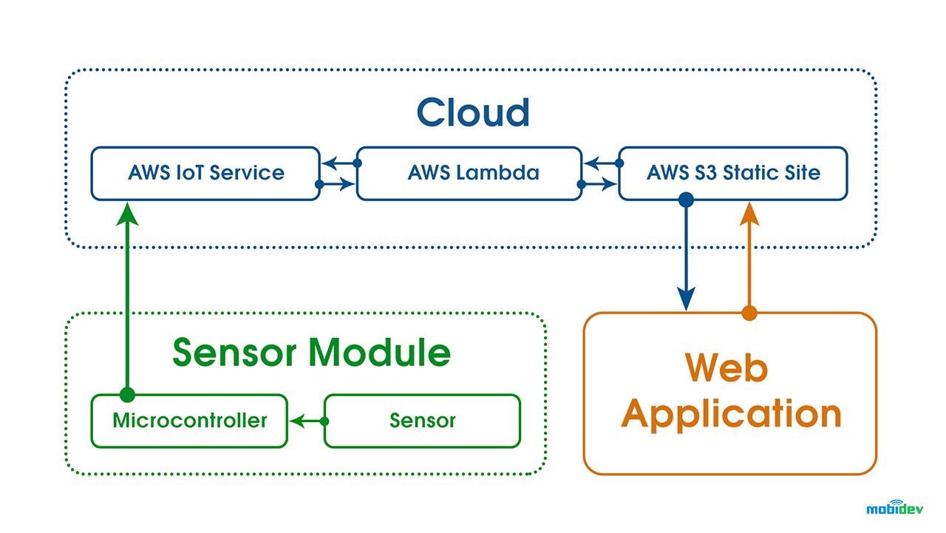

#### **Effective Utilization Of Parking Space**

There is no denying the fact that there is a huge difference between the number of vehicles and parking spaces in the city. The increasing construction within and nearby areas have further widened this gap. The IoT-based smart parking system has effectively utilized parking spaces, and users can easily book & park vehicles without any hassle.

#### **Minimal Street Parking**

Less parking spaces than the total number of vehicles and ineffective management are the biggest reasons for high street parking. With IoT-based smart parking system development, entrepreneurs are reducing users' parking hassle and reducing the parking on the streets. Smart parking solutions effectively reduce congestion on the streets and avoid unnecessary traffic.

#### **Reduced Waiting Period**

Due to the non-regulation of the parking spaces, people have to wait to find a parking space, thus resulting in higher parking on the streets. A higher waiting period results in unwanted fuel wastage and increased stress levels. With IoT-based smart parking system solutions, users can book their parking spot in advance thus reducing the waiting period and on-street parking.

### **IoT-Based Smart Parking System Development For Various Sectors**

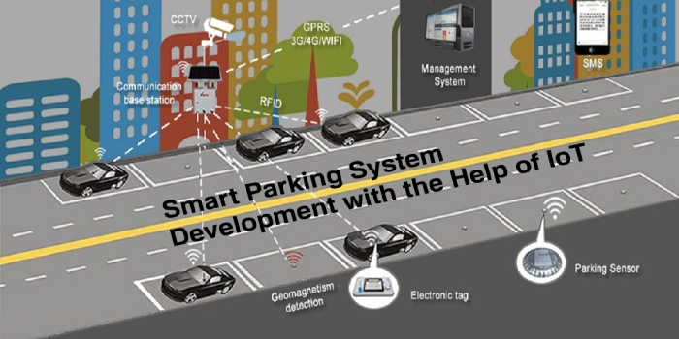

Various sectors have shown interest in IoT-based smart parking system development for effectively managing parking spaces. These software solutions can be deployed anywhere to manage parking spaces and provide users with real-time parking solutions. Here’s a list of sectors where IoT-based smart parking systems can be deployed;

* Government Buildings
* Residential Building
* Sports Stadium
* Municipality Councils
* Commercial Parking Operators
* Enterprises
* Mega Retail Stores
* Shopping Malls
* Hospitals

### **Smart Parking App Development Cost**

The smart parking app development cost depends upon various factors. We have listed some of the major factors that directly impact the project development cost to ease your struggle. As a business owner, you can evaluate all these factors to know how much your smart parking solution will cost.

**The IoT-based smart parking system development cost depends upon:**

* Project complexity
* Add-on features of a smart parking app
* Security features
* Location of the development company
* Per hour development charges
* Development method, i.e., Scratch or Whitelabel solution
* Technology stack
* API integration
* Any additional services required

You can connect with a trusted, smart parking app development company like [**RisingMax Inc**](https://risingmax.com/)., to know the overall project development cost. Our professional team is well-versed with the leading technologies and has successfully built smart parking solutions for our customers over the years. Based on your project needs and business model, our team will suggest the best tech stack, the time needed, and the development cost after the initial project discussion.

**Complete Code to Create a Smart Parking Management Project in Python**

#Import Time

import time

Vehicle_Number=['XXXX-XX-XXXX']

Vehicle_Type=['Bike']

vehicle_Name=['Intruder']

Owner_Name=['Unknown']

Date=['22-22-3636']

Time=['22:22:22']

bikes=100

cars=250

bicycles=78

def main():

global bikes,cars,bicycles

try:

while True:

print("----------------------------------------------------------------------------------------")

print("\t\tParking Management System")

print("----------------------------------------------------------------------------------------")

print("1.Vehicle Entry")

print("2.Remove Entry" )

print("3.View Parked Vehicle ")

print("4.View Left Parking Space ")

print("5.Amount Details ")

print("6.Bill")

print ("7.Close Programme ")

print ("+---------------------------------------------+")

ch=int(input("\tSelect option:"))

if ch==1:

no=True

while no==True:

no=not True

Vehicle_Number.append(Vno)

else:

print("###### Enter Valid Vehicle Number ######")

typee=True while typee==True: Vtype=str(input("\tEnter vehicle type(Bicycle=A/Bike=B/Car=C):")).lower()

print("###### Please Enter Owner Name ######")

else:

Owner_Name.append(OName)

o=not True

)

t=not True

print("\n............................................................Record detail saved..................................................................")

elif ch==2:

no=True

while no==True:

Vno=input("\tEnter vehicle number to Delete(XXXX-XX-XXXX) - ").upper()

if Vno=="":

print("###### Enter Vehicle No. ######")

elif len(Vno)==12:

if Vno in Vehicle_Number:

i=Vehicle_Number.index(Vno)

Vehicle_Number.pop(i)

Vehicle_Type.pop(i)

vehicle_Name.pop(i)

Owner_Name.pop(i)

Date.pop(i)

Time.pop(i)

no=not True

print("\n............................................................Removed Sucessfully..................................................................")

elif Vno not in Vehicle_Number:

print("###### No Such Entry ######")

else:

print("Error")

else:

print("###### Enter Valid Vehicle Number ######")

elif ch==3:

count=0

print("----------------------------------------------------------------------------------------------------------------------")

print("\t\t\t\tParked Vehicle")

print("----------------------------------------------------------------------------------------------------------------------")

print("Vehicle No.\tVehicle Type Vehicle Name\t Owner Name\t Date\t\tTime")

print("----------------------------------------------------------------------------------------------------------------------")

for i in range(len(Vehicle_Number)):

count+=1

print(Vehicle_Number[i],"\t ",Vehicle_Type[i],"\t ",vehicle_Name[i],"\t ",Owner_Name[i]," " ,Date[i]," ",Time[i])

print("----------------------------------------------------------------------------------------------------------------------")

print("------------------------------------------ Total Records - ",count,"-------------------------------------------------------")

print("----------------------------------------------------------------------------------------------------------------------")

elif ch==4:

print("----------------------------------------------------------------------------------------------------------------------")

print("\t\t\t\tSpaces Left For Parking")

print("----------------------------------------------------------------------------------------------------------------------")

print("\tSpaces Available for Bicycle - ",bicycles)

print("\tSpaces Available for Bike - ",bikes)

print("\tSpaces Available for Car - ",cars)

print("----------------------------------------------------------------------------------------------------------------------")

elif ch==5:

print("----------------------------------------------------------------------------------------------------------------------")

print("\t\t\t\tParking Rate")

print("----------------------------------------------------------------------------------------------------------------------")

print("*1.Bicycle Rs20 / Hour")

print("*2.Bike Rs40/ Hour")

print("*3.Car Rs60/ Hour")

print("----------------------------------------------------------------------------------------------------------------------")

elif ch==6:

print(".............................................................. Generating Bill ..........................................................................")

no=True

while no==True:

Vno=input("\tEnter vehicle number to Delete(XXXX-XX-XXXX) - ").upper()

if Vno=="":

print("###### Enter Vehicle No. ######")

elif len(Vno)==12:

if Vno in Vehicle_Number:

i=Vehicle_Number.index(Vno)

no=not True

elif Vno not in Vehicle_Number:

print("###### No Such Entry ######")

else:

print("Error")

else:

print("###### Enter Valid Vehicle Number ######")

print("\tVehicle Check in time - ",Time[i])

print("\tVehicle Check in Date - ",Date[i])

print("\tVehicle Type - ",Vehicle_Type[i])

inp=True

amt=0

while inp==True:

hr=input("\tEnter No. of Hours Vehicle Parked - ").lower()

inp=not True

elif int(hr)==0 and Vehicle_Type[i]=="Car":

amt=60

inp=not True

elif int(hr)>=1:

if Vehicle_Type[i]=="Bicycle":

amt=int(hr)*int(20)

inp=not True

elif Vehicle_Type[i]=="Bike":

amt=int(hr)*int(40)

inp=not True

elif Vehicle_Type[i]=="Car":

amt=int(hr)*int(60)

inp=not True

print("\t Parking Charge - ",amt)

ac=18/100*int(amt)

print("\tAdd. charge 18 % - ",ac)

print("\tTotal Charge - ",int(amt)+int(ac))

print("..............................................................Thank you for using our service...........................................................................")

a=input("\tPress Any Key to Proceed - ")

elif ch==7:

print("..............................................................Thank you for using our service...........................................................................")

print(" **********(: Bye Bye :)**********")

break

quit

except:

main()

main

**Output**

